**TEST REPORT – 27.12.2023** [**https://www.pothys.com/**](https://www.pothys.com/)

**iPad issues**

1, Filter issue – Currently filters like price are not properly working since two filter selecting options are available.

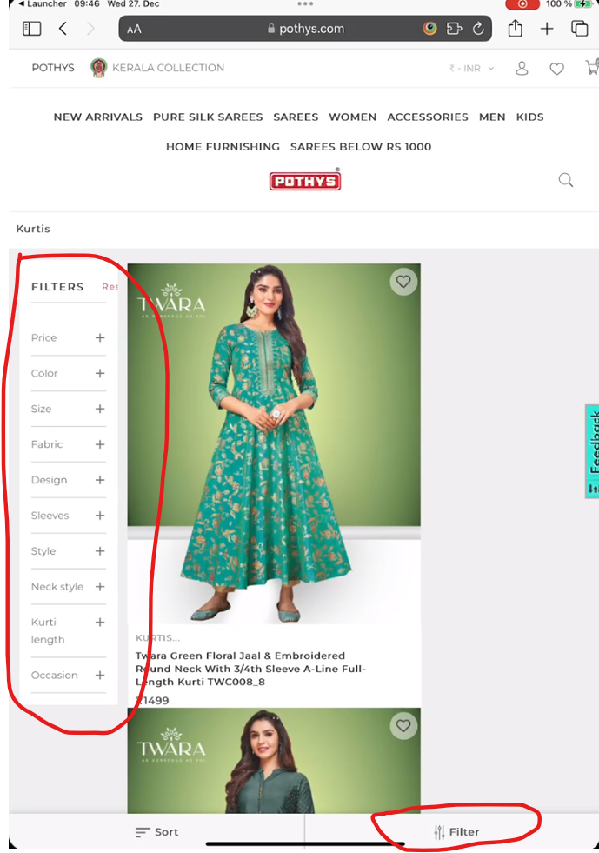

2, this tile style in portrait view is not so good

